**Food Management System for Debre Markos University Cafeteria**

**project report**

**submitted by:**

**1 Habtamu kebede…………………………………TER_1201_10**

**2 Melaku wubetu………………………………………TER_1209_10**

**3 Metasebiya Getaneh………………………………. TER_1211_10**

***In partial fulfilment of the requirement for the award of degree of***

**BACHELOR OF SCIENCE DEGREE IN SOFTWARE ENGINEERING**

**Under the guidance of**

**Addisu Mesfin (MSC)**

**____________**

**Advisor’s signature**



**DEBREMARKOS UNIIVERSITY**

**Institute of technology**

**SCHOOL OF COMPUTING**

**ACADAMIC PROGRAM OF SOFTWARE Engineering**

**Debre Markos Ethiopia**

**July,2022**

# **Declaration**

We hereby to declare that this project is entitled Food management system for Debre Markos university is our own work.it is being submitted in partial fulfilment of the Academic requirements for the bachelor degree in software engineering the result of our project is carried out under supervision of M.R Addisu Mesfin

Candidate’s name signature Date

Habtamu kebede _________ ____________

Melaku wubetu _________ ____________

Metasebiya Getaneh ___________ ___________

This has been submitted for examination with our approval

Mr. Addisu Mesfin ____________ _______________

Advisor signature Date

Examiner ___________ signature __________ Date__________

# **Acknowledgement**

First of all, we would like to thank God for helping through the overall process this project.

Next, we would like to thank Debre Markos university school of computing for giving us support that would involve students in such kinds of problem-solving solutions.

Our special thanks go to our advisor Mr. Addisu Mesfin for his useful and valuable support, encouragement and hints in every step of the way.

Finally, we would like to thank the stake holders who provide us with necessary information.

Table of Contents

Declaration i

Acknowledgement ii

List of acronyms viii

Abstract ix

CHAPTER ONE 1

1 INTRODUCTION 1

1.1 Background of the project 1

1.2 Statement of the problem 1

1.3 Objective of the project 2

1.3.1 General objective 2

1.3.2 Specific objective 2

1.4 Scope of the project 2

1.5 significance of the project 2

1.6 Tools and methodology 3

1.6.1 Data collection methodology 3

1.6.2 Programming language to be used 3

1.6.3 System requirements 4

1.6.4 System modelling tools 5

1.7 Feasibility study 5

1.7.1 Technical feasibility 5

1.7.2 Operational feasibility 5

1.7.3 Economic feasibility 5

1.7.4 Legal feasibility 6

CHAPTER 2 7

2 System analysis 7

2.1 Overview of the existing system 7

2.2 System requirement specification 7

2.3 Functional requirements 7

2.4 Non-functional requirements 8

2.5 overview of the proposed system 10

2.6 Business rule identification 10

2.7 System requirement analysis 12

2.8 Actors and use case identification 12

2.9 use case diagram 15

2.10 Use case diagram description 16

2.11 Sequence diagram 29

2.12 Activity diagram 32

2.13 Analysis class diagram 36

2.14 State machine diagram 38

CHAPTER 3 40

3. System design 40

3.1 design class Diagram 40

3.2 physical data model 42

3.3 user interface design 44

3.4 deployment diagram 47

3.5 component diagram 48

3.6 communication/collaboration diagram 49

CHAPTER 4 51

4 Implementation 51

4.1 Overview of the programming language 51

4.2 Algorithms Used 51

4.3 sample code for register incoming food item 52

CHAPTER 5 59

5.1 Testing 59

CHAPTER 6 61

6. Conclusion and Recommendations 61

6.1. Conclusion 61

6.2Recommendation and Future Enhancement 61

6.2.1. Recommendation 61

6.2.2. Future Enhancement 61

References 62

Appendences 63

**List of tables**

Table 2.1 use case table 14

Table 2.2 use case description for view request 16

Table 2.3 register non-café students 17

Table 2.4 Assign daily food menu 18

Table 2.5 Give meal card 19

Table 2.6 request materials lack 20

Table 2.7 assign special food 21

Table 2.8 Request to finance 22

Table 2.9 view report 23

Table 2.10 request ailing students 24

Table 2.11 register special food 25

Table 2.12 register punished students 26

Table 2.13 internship request 27

Table 2.14 create account 28

**List of figures**

Figure2. 1 Use case diagram 15

Figure2. 2 Sequence diagram for head cafe 29

Figure2. 3 sequence diagram for student service directorate 30

Figure2. 4 Sequence diagram for web Admin 31

Figure2. 5 activity diagram for register non-café 32

Figure2. 6 activity diagram for register non-café 33

Figure2. 7 activity diagram for register incoming materials 34

Figure2. 8 Activity diagram for create account 35

Figure 2. 9 Analysis class Diagram 37

Figure2. 10 state machine diagram for register non café 38

Figure2. 11 State machine diagram for create account 39

Figure3. 1 Design class diagram 41

Figure3. 2 physical data model for ailing students 42

Figure3. 3 physical data model for non-café students 42

Figure3. 4 physical data model for daily expenditure 43

Figure3. 5 physical data model for log file 43

Figure3. 6 main home page interface 44

Figure3.7register incoming material 45

Figure3. 8 request material user interface 46

Figure3. 9 Deployment diagram 47

Figure3. 10 Component diagram 48

Figure3. 11 collaboration diagram for head café assigning daily menu 49

Figure3. 12 Collaboration diagram for web admin creating account 49

Figure3. 13 Collaboration diagram for student service directorate 50

Figure 4. 1 sample test for login 59

Figure 4. 2 sample test for registering incoming food 60

# 

# List of acronyms

GHz……………………………………. giga hertz

CSS…………………………………...cascading style sheet

UML………………………………. unified modelling language

GB…………………………………………Gigabyte

HTML……………………………………Hypertext markup language

MYSQL…………………………………My structured query language

RAM……………………………………. Random access memory

EID………………………………………. employee identification

URL…………………………………………uniform resource location

SQL…………………………………………. structured query language

Stud_id………………………………………. student identification

# **Abstract**

Debre Markos University student’s food service gives a food service for the students. Addressing of food service for the student’s gets difficult when workers use manual system to conduct the service; student service directorate get student’s information from registrar office using either soft copy or hard copy, and he/she distribute this information for head café, item store manager and other remaining stakeholders. in order to perform what they do for students after head café get student’s information, he/she assign daily student’s food menu based on their numbers and send it to item store manager and item store manager see the ordered item food then food items are send to chef after that item store calculate how much food items are left and how much are left through manual way.

This project emphasizes on the manual system that is described above. After studying this manual system by using different types of methodologies we have developed this project that decrease the workload of workers and increasing information exchange rate by automating some of the activities that are done manually. Generally, this system has major mechanisms to get current student’s information fast, enables item store manager to view bin balance, to register incoming food items and material, and head café to assign student’s daily menu, to register non cafe students, to assign meal card for students, student directorate to register punish students, to scale-out food scale.

# **CHAPTER ONE**

# **1 INTRODUCTION**

Food management system is the process of addressing and managing food for a target user. when we talk about managing food, the main task we take into consideration is the difficulty if the supplier does not know the number of consumers. Because of this reason most organizations might get loss in their services. from those organizations’ universities are places that provide food service for large number of students. And the main focus of this project is automating the food management system for Debre Markos University.

# **1.1 Background of the project**

Debre Markos University is one of the governmental higher educational institutions that gives services for the students and the community. Addressing food service for students is one of the services from it serves. To do this task the university build up many divisions of responsibilities, among those: student service directorate, food store, head café, ticker head, chef, student union and other different participants are the stake holders. Even though different participants are assigned at different places, their main goal is addressing food for students. To do this they have to send number of students to federal and the federal funds for food services. After the university gets its budget, the stakeholders plan annual food menu and make a bid to get food materials from outside body. Those suppliers may be merchants or enterprises. After they get the raw materials from the suppliers, they communicate each other to serve food for students. When they do these activities, tasks are done through manual way, which makes it difficult to manage the food service. so, we are initiated to do a web-based food management system for Debre Markos University cafeteria.

# **1.2 Statement of the problem**

Even if the technology is arising from years to years the cafeteria of Debre Markos university addressing system of food for students and its management of food items have some problems and we stated them as follows:

* The student service directorate receives number of students from registrar in manual way. This is time consuming to get necessary information fast.
* The head café does not get current status of student’s information fast so it is difficult to order daily menu because it might lead to wastage of food.
* Item store manager gets it hard to make bin balance; all mathematical operation is done using calculators and papers which makes them prone to errors.
* Daily food menu from the head cafe goes to store manager in manual way
* It is difficult to know the number of students who left the university’s compound due to vacation, internship or withdrawal
* When the workers in the cafeteria make monthly and annual reports they work in a manual way.

# **1.3 Objective of the project**

## **1.3.1 General objective**

The general objective of this project is developing web-based food management system of students in Debre Markos university cafeteria.

## **1.3.2 Specific objective**

Specific objectives are designed to give answers for the question what advantage will the system provide after it is accomplished; what kind of situation is it going to create for users. Specific objectives of the system are listed as follows:

* To develop a mechanism that enables registrar office, student service directorate, student food service, head café, item store manager, enterprise, ticker head and the forth to communicate each other online.
* To make daily food menu of the students using the system.
* To generate annual and monthly report by the system
* To make back up of the system and restore it when it is necessary.
* To give meal card for students.
* To Create a mechanism for calculating bin balance

# **1.4 Scope of the project**

The scope of this project is concentrated on how to facilitate student’s food management system activities and application of cafeteria in an easy, efficient and functional way. The following lists are the scope of the project:

* Registering and displaying detail information about the employees of cafeteria and the students
* Allow employees of the cafeteria and the administrator to login with their own password
* Keep students and cafeteria file secured
* Information sharing among employees
* Update record of correctional program attained by employees.
* Update record of correctional program attained by students

# **1.5 significance of the project**

The proposed system delivers different function for the university:

* Reduce work load of student’s food service workers like head café, head ticker, item store manager
* Since the number of students who are going for internship or trip is known by the system as soon as possible, it will reduce the wastage of food.
* Reduce the time needed to accomplish some tasks for example registration of students for food service
* Faster request response between stake holders
* The possibility of fraud on universities property will be reduced since everything found in the item store will be registered on the system
* It is profitable according to saving properties like paper and pen since the system is going to replace the paper work.

# **1.6 Tools and methodology**

## **1.6.1 Data collection methodology**

Throughout the work of this project, we used different methods for collecting information and as well as gathering data those are:

* Interview: we went to the university’s different stake holders specially those who work around the cafeteria and interviewed them.
* Discussion: this is one of the techniques in which we have seated together and discussed on the project how we can perform the system.
* Observation: assessing and analysing the overall system has been carried out by observing the current working system we have gone to DMU cafeteria office and seen how their system works and we have conducted physical observation how data are Handled and information of the system kept in the system
* Referring documents: we have collected some documents through the internet.

## **1.6.2 Programming language to be used**

We will use the following programming language in our system

Back-end design method will be:

PHP- for server-side scripting.

MYSQL (XAMPP) -used to as a database tool for our system.

Front end design method:

The user interface will be developed using HTML, CSS and Java script.

HTML- used to create a web page for the system.

CSS- we will use CSS to apply a set of style characteristics to our system

JavaScript- we will use java script for client-side scripting such as form validation and different pop-up messages.

Since we are going to use the above programming language, we will have a cost advantage. The other reason is they are license free and there is no royalty fee involved.

## **1.6.3 System requirements**

There are hardware and software requirements of the system.

The main Hardware requirement we need is computer, which is used to develop our web application on food management system and the minimum computer hardware specifications are:

* Processor- core i3 @2Ghz
* Ram-4GB
* Hard drive- 200 GB
* Operating system-windows 10

Other hardware requirements beside computer are:

* Backup device- USB flash disk
* Other materials- paper and pen

The software requirements are as follows:

* XAMPP server: we use XAMPP server to manage our server settings.

XAMPP server is an open-source software which is used to run and test application before being uploaded on the actual server.

The advantage of XAMPP software is, it is easily configurable with the built-in tools.

* Visual studio code (vs code) - we use visual studio code text editor to write our code.
* Microsoft word 2019- we use Microsoft word 2019 to write the documentation about the proposed system from the beginning up to the end of the project.
* Microsoft power point 2019- we will use Microsoft power point for presentation purpose.
* Browsers
* Mozilla Firefox
* Google chrome
* 0Brave browser

## **1.6.4 System modelling tools**

* Draw.io- we used draw.io software to draw different uniform modelling language (UML) which is necessary to structure the system.

# **1.7 Feasibility study**

A feasibility is an analysis of how successfully a project can be completed, accounting for factors that affect it such as economic, technological, legal and [1].

* A feasibility study should management with enough information to decide
* Whether the project can be done
* Whether the intended project will benefit its intended users and organization
* What are alternatives among the solutions chosen.

## **1.7.1 Technical feasibility**

At the implementation stage we should use the latest technology tools. And we should check if the technology exists or not. Or if it exists within given resource constraints.

During testing technical feasibility should consider the following essential questions:

* Does the technology exist?
* Is it possible within given resource constraints?
* Are the current technical resources sufficient for the new system?

## **1.7.2 Operational feasibility**

Operational feasibility is the measure of how well our proposed system solves the existing manual systems problem. After automating the system, it addresses basic problems of the organization, particularly students’ information can be handled easily, which reduces the workload of the stuff.

The system will fit the system and user requirement with regard to development schedule, delivery date, and existing business process due to our system will be operationally feasible.

## **1.7.3 Economic feasibility**

Economic feasibility is determined by identifying by costs and benefits associated with the system, assigning values to them, calculating future cash flows and measuring the financial value of the project. Since we are going to develop web-based system, information will be gained fast, and it saves time and cost and facilitates work process for the university.

## **1.7.4 Legal feasibility**

The legal feasibility determines whether the system conflicts with the legal requirement of the institution or not. We will build a system that will not conflict with the rules and regulations of Debre Markos University, rather it gives benefit to the university by making part of its work easy.

# 

# **CHAPTER 2**

# **2 System analysis**

System analysis is the process by which individual studies a system such that an information system can be analysed, modelled, and logical alternative can be chosen.

# **2.1 Overview of the existing system**

Now a day’s most of the student’s food services is performed through manual system. The current food management system in Debre Markos University looks like as described as follows:

The university accepts budget from federal according to the number of students. Then the student’s food directorate make annual plan of student’s food menu based on the budget.

Student’s daily food consumption is scale up by considering fifteen birr per day for each student. The incoming materials from suppliers placed at food store and the registration of the items held on paper. When new materials are imported the student service directorate, student union, head café, store worker and merchant have to check the materials. Then the café head order food items based on daily menu to the store manager. After the store manager receives report from the head café, he/she gives the item based on the daily menu received from the head café. After they provide the necessary items to the cafeteria the store manager then calculates how much he/she gives and how much left in the store.

Head café and student union are responsible for checking the quality of items received from the merchant and provide it to chef. If the chef feels there is a problem with the items, he/she reports it to the head café. And the head café reports the situation to the store manager and the store manager deals with the suppliers and tell them to provide quality materials for future or even might return materials.

# **2.2 System requirement specification**

System requirement specification is a document that describes a nature of a project, software or application. System requirement specification establishes the basis for an agreement between customers and contractors or suppliers on how the software product should [2]

# **2.3 Functional requirements**

Functional requirements are product features or functions that developers must implement to enable users to accomplish their tasks. So, it is important to make them clear both for the development team and the stakeholders. Generally, functional requirements describe system behaviour under [3]

Under functional requirements there are user requirements and system requirements.

User requirements are requirements in which the system must fulfill for users. Some of these are listed below:

* The system should accept user name and password of a stakeholder.
* The system should give an exclusive privilege to the administrator to register eligible institutions’ users.
* There system shall validate and authenticate the user’s user name and password.
* The system shall allow item store manager to check bin balance, to register incoming items, to view remaining items and to replay to head café for daily menu request.
* The system shall allow the student service directorate to register students and to punish them and to report different situations to head café.
* The system shall allow the head café to give meal card, to assign students daily food menu, to send requests to the item store manager, to view students’ current information, to view registered food and to make report.
* The system shall allow the president or vice president to view annual report.

System requirements are statements that identify the functionality that is needed by a system in order to satisfy customer’s requirements. System requirements are a broad and also narrow subject that could be implemented to many items.

Some of the system requirements of our project are listed below: System requirements are the most effective way of meeting the users’ needs and reducing the cost of implementation.

* The minimum requirement that the system needs is operating system should be windows ten.
* The users of the system should be a little more familiar with computer to use the system properly.
* Users should login to the system using their username and password only
* Users shall update their account.
* Users should be members of Debre Markos University.
* Users should insert valid data.
* After using the system, the user should logout from the system.

# **2.4 Non-functional requirements**

Non-functional requirements define system attributes such as security, reliability, performance, maintainability, scalability, and usability. They serve as constraints or restrictions on the design of the system across the different backlogs.

Non-functional requirements of the system are as described as below:

* **Performance:** web-based student food management system allows users of the system to access, send and calculate necessary tasks with a high speed.
* **Reliability:** since the system needs to have backup servers it shall be accessible at any time with the exception of infrastructure failure. This requirement shall be provided for and by Debre Markos university technology systems.
* **Security:** since the system provides security for database an authorized users should not access the systems database.
* **Integrity:** Debre Markos university food management system is only accessible by an authorized user of the system to update, delete, modify or access the system.
* **User access:** The system provides easy user interface for users by avoiding complex buttons and links. And it works in user understandable format.
* **Reusability:** The system shall be well documented in order for new administrators to change content as needed. Also, the system shall be designed in such a way that the administrators may modify content without the need to modify the code.
* **Compatibility:** The system shall be compatible with different internet browser like internet explorer, Mozilla Firefox, Brave and google chrome.
* **Resource utilization:** The system shall be accessible from any time of computer with an active internet connection, adequate hard drive and memory.
* **Authentication and authorization:** The system shall authenticate the user and provide authorization facilities by asking username and password to check whether the user is authorized to access resource or to perform operation.
* **Availability:** The system should be available 24/7.
* **Maintainability:** there should be a backup server for the system when failure happens and when it is needed to be recovered. The system should be easily maintainable by administrator easily by using user interface and also the system can be maintained by eligible programmers when it is needed.
* **Easy to use:** The system is simple to use and can be easily learned.

Generally,

* The system has well organized information storage and mechanism
* The language used to operate the system is English which is internationally understandable language and which is able to increase readability.
* The system provides quick and easy and quick information analysis which maximize work efficiency.
* The system is able to manage all incoming information from the data.

# **2.5 overview of the proposed system**

The system is proposed to computerize the working environment of existing system and to overcome the problem regarded with manual work and to benefit the community of cafeteria in common.

The following lists are overview of the proposed system:

* Saving time which is spent on searching records by hand.
* Reducing space that is occupied by manual document.
* Helping the administrator to have any easy access and control over the system.
* Generating report when it is needed by the stake holders.
* Online feedback between the community of the cafeteria.
* Registering, searching, updating and keep all the file in safe way.

# **2.6 Business rule identification**

A business rule is an organizational entity involved in the delivery of goods and services to consumers.

Business rule describes system policy and procedure. They are usually expressed at atomic level. That is, they cannot be broken down any further.

Business rules of food management system for Debre Markos cafeteria are listed below.

**Name**: -determine quality of materials and foods

**ID**: -BR-1:

**Description**: -this business rule states that supplier’s goods and materials are received if and only if and only if the quality of goods and materials have approved by the curators.

**Name**: -determine daily food menu change

**ID: -BR-2**

**Description: -**This business rule describes that daily food menu will change if and only if there is shortage of supply for that specific day specially interruption of electricity.

**Name**: -determine price of good and materials

**ID: -BR-3**

**Description: -**This business rule describes that the price of goods and materials should be constant till the contract has finished.

**Name**: -determine suppliers

**ID: -BR-4**

**Description: -**This business rule describes that supplier who supply goods and materials with minimum price are selected.

**Name**: -determine daily expenditure

**ID: -BR-5**

**Description: -**This business rule describes that the daily food expenditure is determined by number of students.

**Name**: -punishment of undisciplined workers

**ID: -BR-6**

**Description: -**This business rule describes that a person who break the rule and regulation of Debre Markos University Student food service system will punish.

**Name**: -determine replace meal card

**ID: -BR-7**

**Description: -**This business rule describes that cafeteria user students are on the system and when they lose their meal card they will be charged more

**Name**: -determine validating daily expenditure

**ID: -BR-8**

**Description: -**This business rule describes that the daily food expenditure is leave from Item store manager if and only if student union, Item store manager, and head café put their signature at the paper.

**Name**: -determine assigning meal card

**ID: -BR-9**

**Description: -**This business rule describes that student who are cafeteria users allowed to have only one meal card

# **2.7 System requirement analysis**

System requirement analysis is the process of obtaining a through and detailed understanding of business need as defined in project origination and captured in a business case and to break it down in to discrete requirements which are then clearly defined, reviewed and agreed up on the customer decision.

# **2.8 Actors and use case identification**

**Actor**: in a use case diagram is an entity that performs role in one given system. An actor could be a person, an organization or an external system that can be usually drawn as a skeleton. Actors of the system are:

* Web admin
* Student service directorate
* Department Head
* Student union
* Registrar
* President
* Vice-president
* Merchant
* Enterprise
* Chef
* Ticker head
* Student
* Head cafe
* Item store manager
* Nurse
* Proctor
* Purchase and procurement
* Finance

**Use case:** represents a function or an action within the system it is drawn oval and named with function. Our use cases are listed below:

|  |  |  |  |
| --- | --- | --- | --- |
| ID | |  | | --- | | Use Case Name | | Include |
| UC1 | Login |  |
| UC2 | Register incoming food | UC1 |
| UC3 | View remaining food item | UC1 |
| UC4 | View daily menu | UC1 |
| UC5 | Register incoming materials | UC1 |
| UC6 | View Request | UC1 |
| UC7 | Register non café students | UC1 |
| UC8 | Assign daily menu | UC1 |
| UC9 | Make Report | UC1 |
| UC10 | Generate meal card | UC1 |
| UC11 | Update internship request | UC1 |
| UC12 | Request material lack | UC1 |
| UC13 | Assign special food | UC1 |
| UC14 | Upload students list | UC1 |
| UC15 | Request to finance | UC1 |
| UC16 | View report | UC1 |
| UC17 | Request material lack | UC1 |
| UC18 | Pay for non-cafe | UC1 |
| UC19 | Register Special food user | UC1 |
| UC20 | Check daily food menu | UC1 |
| UC21 | Register students | UC1 |
| UC22 | Approve finance request | UC1 |
| UC23 | Post notice | UC1 |
| UC24 | Register leave students | UC1 |
| UC25 | Register punished students | UC1 |
| UC26 | Check out food scale | UC1 |
| UC27 | Internship request | UC1 |
| UC28 | View log event | UC1 |
| UC29 | Use backup | UC1 |
| UC30 | Create account | UC1 |
| UC31 | Manage profiles | UC1 |
| UC32 | Send feedback | UC1 |
| UC33 | Register irregular food user | UC1 |
| UC34 | View shortage of item | UC1 |
| UC35 | View daily eaten food | UC1 |
| UC36 | Approve material lack request | UC1 |
| UC37 | View material lack request | UC1 |
| UC38 | View import item | UC1 |
| UC39 | Update student status | UC1 |
| UC40 | Reject request | UC1 |
| UC41 | Accept request | UC1 |
| UC42 | View feedback | UC1 |

Table 2.1 use case table

# **2.9 use case diagram**

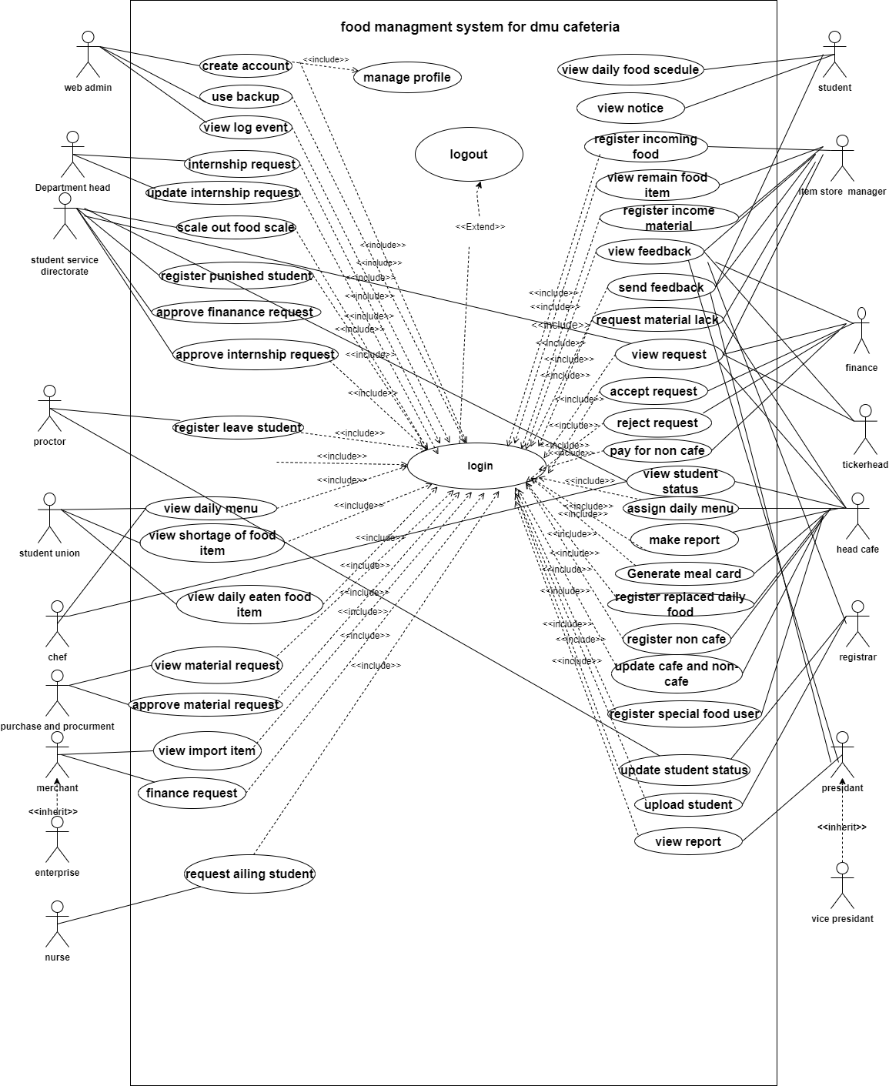**­­**

Figure2. 1 Use case diagram

# **2.10 Use case diagram description**

|  |  |
| --- | --- |
| Use case | View request |
| ID | UC6 |
| Include | UC1 |
| Actor | ticker head, student service directorate, finance, item store manager |
| Description | All the above listed actors view request to do their specified task |
| Precondition | Login to the system using his/her username and password |
| Post condition | Get full information |
| Basic course of action | 1. Look at the site on the address bar of the browser. 2. Enter user name and password 3. Click on view request tab on the menu and select message from stakeholder. 4. End of the use case. |
| Alternative course of action | A: If login detail is incomplete or mismatch at step 2. |
| A1: the system displays error message.  A2: actors must look and fix those errors.  A3: The use case continues at step 2. |

Table 2.2 use case description for view request

|  |  |
| --- | --- |
| Use case | Register non café student |
| ID | UC7 |
| Actor | Head cafe |
| Description | Head café register non café students. |
| Precondition | Login to the system using his/her username and password |
| Post condition | Non café students are registered. |
| Basic course of action | 1. Look at the site on the address bar of the browser. 2. Enter user name and password 3. Click on Register non café students ‘tab on the menu. 4. Fill all the information at the form and click submit. 5. The system displays success message 6. End of use case. |
| Alternative course of action | A: If login detail is incomplete or mismatch at step 2. |
| A1: the system displays error message.  A2: actors must look and fix those errors.  A3: The use case continues at step 2. |
|  | B: if the information is incomplete at step 4. |
| B1: the system displays error message.  B2: actors must look and fix those errors.  B3: The use case continues at step 4. |

Table 2.3 register non-café students

|  |  |
| --- | --- |
| Use case | Assign daily menu |
| ID | UC8 |
| Actor | Head cafe |
| Description | Head café assign daily food menu based on the calendar |
| Precondition | Login to the system using his/her username and password |
| Post condition | Daily foods are assigned. |
| Basic course of action | 1. Look the site on the address bar of the browser. 2. Enter user name and password 3. Click on Assign daily menu tab on the menu. 4. Select the day, food’s good type and their amount. 5. Click submit button. 6. The system displays success message 7. End of use case. |
| Alternative course of action | A: If login detail is incomplete or mismatch at step 2. |
| A1: the system displays error message.  A2: actors must look and fix those errors.  A3: The use case continues at step 2. |
|  | B: if the information is incomplete at step 4. |
| B1: the system displays error message.  B2: actors must look and fix those errors.  B3: The use case continues at step 4. |

Table 2.4 Assign daily food menu

|  |  |
| --- | --- |
| Use case | Give meal card |
| ID | UC10 |
| Actor | Head cafe |
| Description | Head café register students for meal card |
| Precondition | Login to the system using his/her username and password |
| Post condition | Students get meal card. |
| Basic course of action | 1. Look the site on the address bar of the browser. 2. Enter user name and password 3. Click on give meal card tab on the menu. 4. Fill all the required information and click submit button. 5. The system displays success message 6. End of use case. |
| Alternative course of action | A: If login detail is incomplete or mismatch at step 2. |
| A1: the system displays error message.  A2: actors must look and fix those errors.  A3: The use case continues at step 2. |
|  | B: if the information is incomplete at step 4. |
| B1: the system displays error message.  B2: actors must look and fix those errors.  B3: The use case continues at step 4. |

Table 2.5 Give meal card

|  |  |
| --- | --- |
| Use case | Request materials lack |
| ID | UC12 |
| Actor | Head café |
| Description | Head café request material lacks for food store. |
| Precondition | Login to the system using his/her username and password |
| Post condition | Material’s request is sent. |
| Basic course of action | 1. Look the site on the address bar of the browser. 2. Enter user name and password 3. Click on request material lack tab on the menu. 4. Fill all the required information and click submit button. 5. The system displays success message 6. End of use case. |
| Alternative course of action | A: If login detail is incomplete or mismatch at step 2. |
| A1: the system displays error message.  A2: actors must look and fix those errors.  A3: The use case continues at step 2. |
|  | B: if the information is incomplete at step 4. |
| B1: the system displays error message.  B2: actors must look and fix those errors.  B3: The use case continues at step 4. |

Table 2.6 request materials lack

|  |  |
| --- | --- |
| Use case | Assign special food |
| ID | UC13 |
| Actor | Head café |
| Description | Head café assign special food for students who have a special case on his or her health. |
| Precondition | Login to the system using his/her username and password |
| Post condition | Special foods are assigned. |
| Basic course of action | 1. Look the site on the address bar of the browser. 2. Enter user name and password 3. Click on assign special food tab on the menu. 4. Fill all the required information and click submit button. 5. The system displays success message 6. End of use case. |
| Alternative course of action | A: If login detail is incomplete or mismatch at step 2. |
| A1: the system displays error message.  A2: actors must look and fix those errors.  A3: The use case continues at step 2. |
|  | B: if the information is incomplete at step 4. |
| B1: the system displays error message.  B2: actors must look and fix those errors.  B3: The use case continues at step 4. |

Table 2.7 assign special food

|  |  |
| --- | --- |
| Use case | Request to finance. |
| ID | UC15 |
| Actor | Merchant, enterprise |
| Description | Merchant and enterprise request to finance to pay for the goods which they import. |
| Precondition | Login to the system using his/her username and password |
| Post condition | Requests are sent. |
| Basic course of action | 1. Look the site on the address bar of the browser. 2. Enter user name and password 3. Click on Request to finance tab from the menu. 4. Fill all the required information and submit. 5. End of use case. |
| Alternative course of action | A: If login detail is incomplete or mismatch at step 2. |
| A1: the system displays error message.  A2: actors must look and fix those errors.  A3: The use case continues at step 2. |
|  | B: if the information is incomplete at step 4. |
| B1: the system displays error message.  B2: actors must look and fix those errors.  B3: The use case continues at step 4. |

Table 2.8 Request to finance

|  |  |
| --- | --- |
| Use case | View report |
| ID | UC16 |
| Actor | President, vice-president, student’s service directorate |
| Description | President and vice-president view annual report; student’s service directorate view monthly and annual report send from head café. |
| Precondition | Login to the system using his/her username and password |
| Post condition | Reports are viewed. |
| Basic course of action | 1. Look the site on the address bar of the browser. 2. Enter user name and password 3. Click on view reports. 4. End of use case. |
| Alternative course of action | A: If login detail is incomplete or mismatch at step 2. |
| A1: the system displays error message.  A2: actors must look and fix those errors.  A3: The use case continues at step 2. |

Table 2.9 view report

|  |  |
| --- | --- |
| Use case | Request ailing student |
| ID | UC17 |
| Actor | Nurse |
| Description | The nurse checks the student health status and then attach the information to the head cafe. |
| Precondition | Login to the system using his/her username and password |
| Post condition | Get message as he Send successful information to the head café. |
| Basic course of action | 1. Look the site on the address bar of the browser. 2. Enter user name and password 3. Click on request ailment tab on the menu. 4. Fill full information on the form and click submit button. 5. The system displays success message 6. End of use case. |
| Alternative course of action | A: If login detail is incomplete or mismatch at step 2. |
| A1: the system displays error message.  A2: actors must look and fix those errors.  A3: The use case continues at step 2. |
|  | B: if the information is incomplete at step 4. |
| B1: the system displays error message.  B2: actors must look and fix those errors.  B3: The use case continues at step 4. |

Table 2.10 request ailing students

|  |  |
| --- | --- |
| Use case | Register special food |
| ID | UC19 |
| Actor | Student union |
| Description | Student unions register students who do not eat regular food . |
| Precondition | Login to the system using his/her username and password |
| Post condition | Students are registered. |
| Basic course of action | 1. Look the site on the address bar of the browser. 2. Enter user name and password 3. Click on register special food tab on the menu. 4. Fill all the required information and click submit button. 5. The system displays success message 6. End of use case. |
| Alternative course of action | A: If login detail is incomplete or mismatch at step 2. |
| A1: the system displays error message.  A2: actors must look and fix those errors.  A3: The use case continues at step 2. |
|  | B: if the information is incomplete at step 4. |
| B1: the system displays error message.  B2: actors must look and fix those errors.  B3: The use case continues at step 4. |

Table 2.11 register special food

|  |  |
| --- | --- |
| Use case | Register punished students |
| ID | UC25 |
| Actor | Student service directorate |
| Description | Student service directorate announce students’ who is dismiss from the university increase of discipline. |
| Precondition | Login to the system using his/her username and password |
| Post condition | Get message as he Send successful information to the head café. |
| Basic course of action | 1. Look the site on the address bar of the browser. 2. Enter user name and password 3. Click on request ailment tab on the menu. 4. Fill full information on the form and click submit button. 5. The system displays success message 6. End of use case. |
| Alternative course of action | A: If login detail is incomplete or mismatch at step 2. |
| A1: the system displays error message.  A2: actors must look and fix those errors.  A3: The use case continues at step 2. |
| B: if the information is incomplete at step 4. |
| B1: the system displays error message.  B2: actors must look and fix those errors.  B3: The use case continues at step 4. |

Table 2.12 register punished students

|  |  |
| --- | --- |
| Use case | Internship Request |
| ID | UC27 |
| Actor | department |
| Description | department announces number of students those who are gone to internship to the student service directorate. |
| Precondition | Login to the system using his/her username and password |
| Post condition | Get successful message that shows weather he was sent correct student information or not. |
| Basic course of action | 1. Look the site on the address bar of the browser. 2. Enter user name and password 3. Click on send request button 4. Fill all the required information on the form then send to student service directorate. 5. End of use case. |
| Alternative course of action | A: If login detail is incomplete or mismatch at step 2. |
| A1: the system displays error message.  A2: actors must look and fix those errors.  A3: The use case continues at step 2. |
|  | B: if the information is incomplete at step 4. |
| B1: the system displays error message.  B2: actors must look and fix those errors.  B3: The use case continues at step 4. |

Table 2.13 internship request

|  |  |
| --- | --- |
| Use case | Create account |
| ID | UC30 |
| Actor | Web admin |
| Description | Web admin create account for an eligible user of the system |
| Precondition | Login to the system using his/her username and password |
| Post condition | Users get account. |
| Basic course of action | 1. Look the site on the address bar of the browser. 2. Enter user name and password 3. Click on create account button 4. Fill all the required information on the form then click submit it. 5. End of use case. |
| Alternative course of action | A: If login detail is incomplete or mismatch at step 2. |
| A1: the system displays error message.  A2: actors must look and fix those errors.  A3: The use case continues at step 2. |
|  | B: if the information is incomplete at step 4. |
| B1: the system displays error message.  B2: actors must look and fix those errors.  B3: The use case continues at step 4. |

Table 2.14 create account

# **2.11 Sequence diagram**

It is an interaction diagram that details how operations are carried out: what messages are sent and when. Sequence diagrams are organized according to time. The time progress as we go down to the [4]. 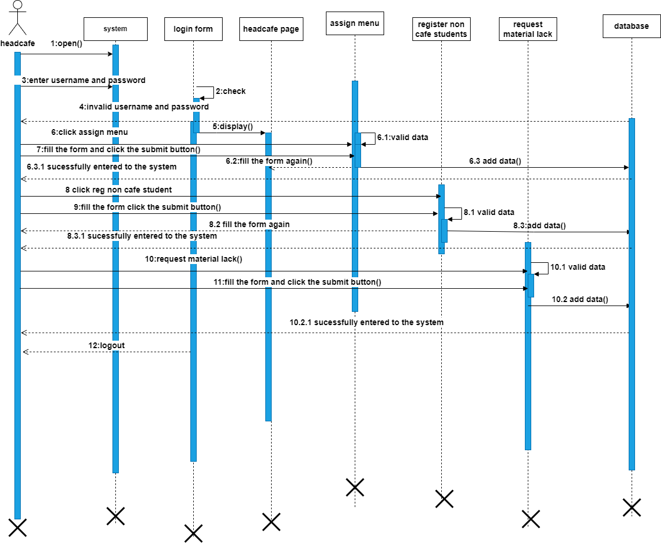

Figure2. 2 Sequence diagram for head cafe

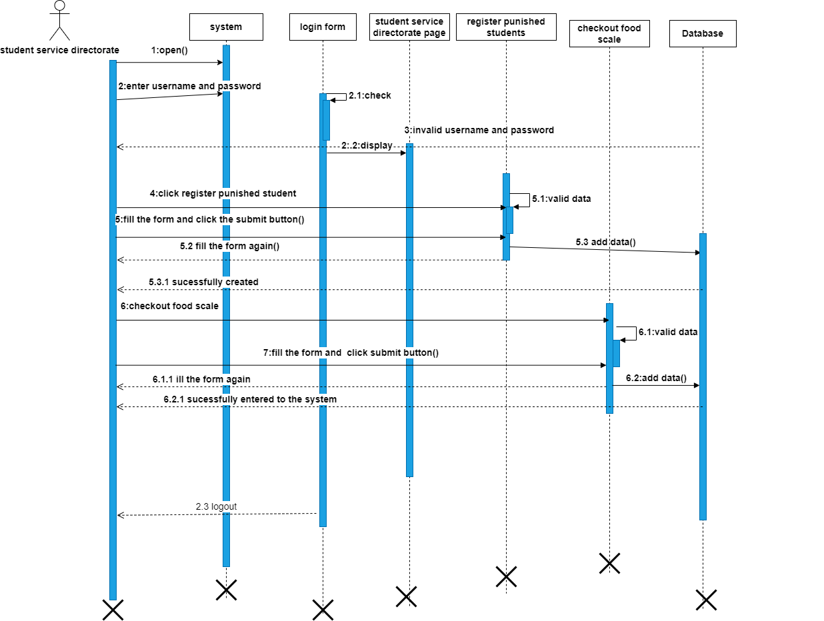

Figure2. 3 sequence diagram for student service directorate

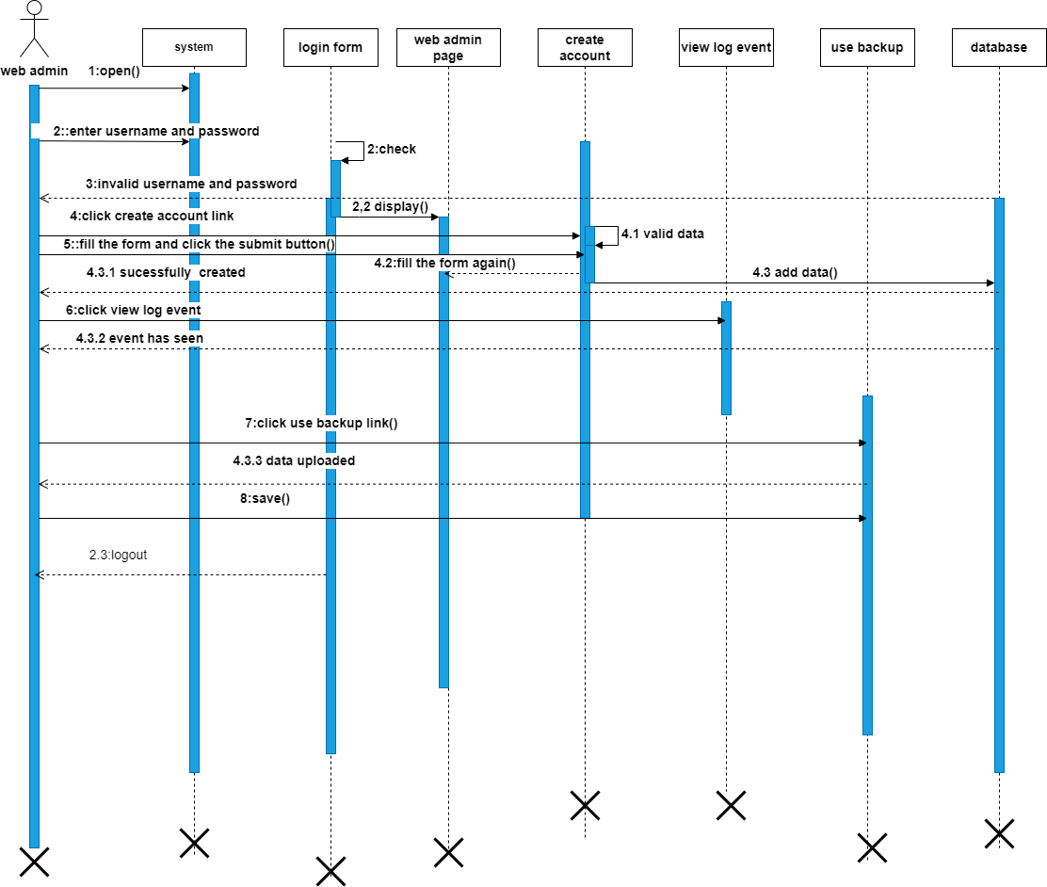

Figure2. 4 Sequence diagram for web Admin

# **2.12 Activity diagram**

An activity diagram is a behavioural diagram that depicts the behaviour of a system. An activity diagram portrays the control flow from a start point to a finish point showing the various decision paths that exist while the activity is [5]

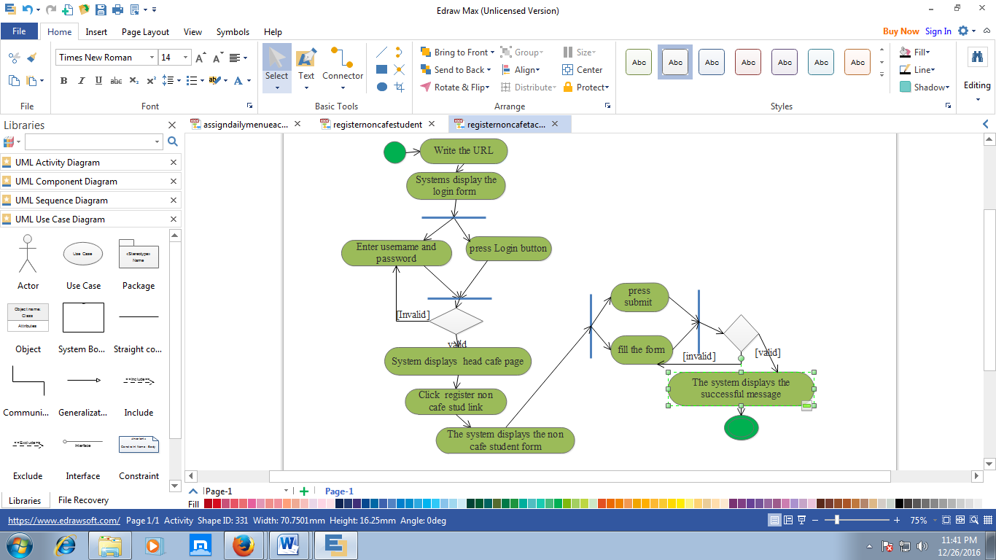

Figure2. 5 activity diagram for register non-café

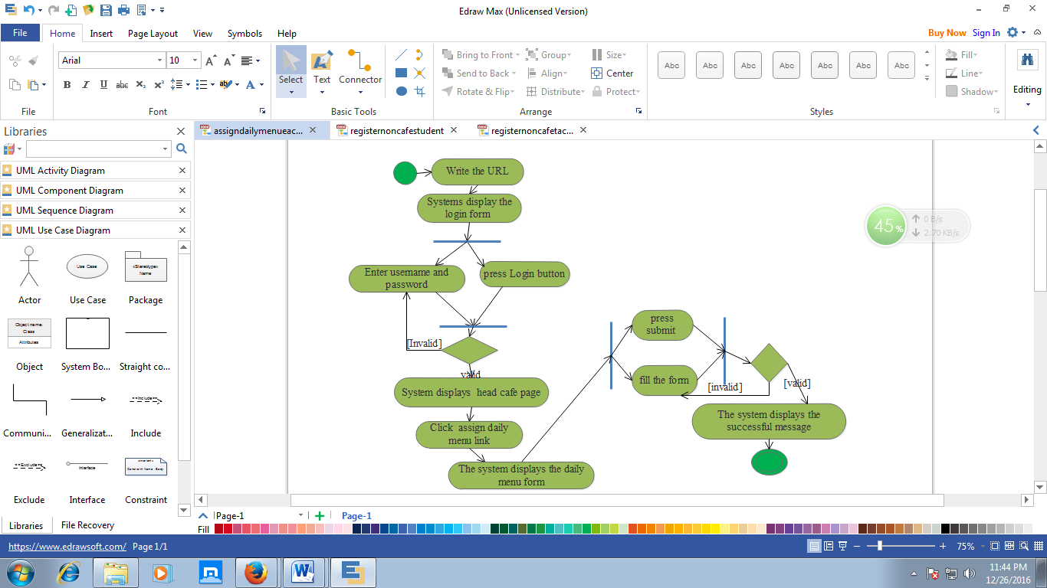

Figure2. 6 activity diagram for register non-café

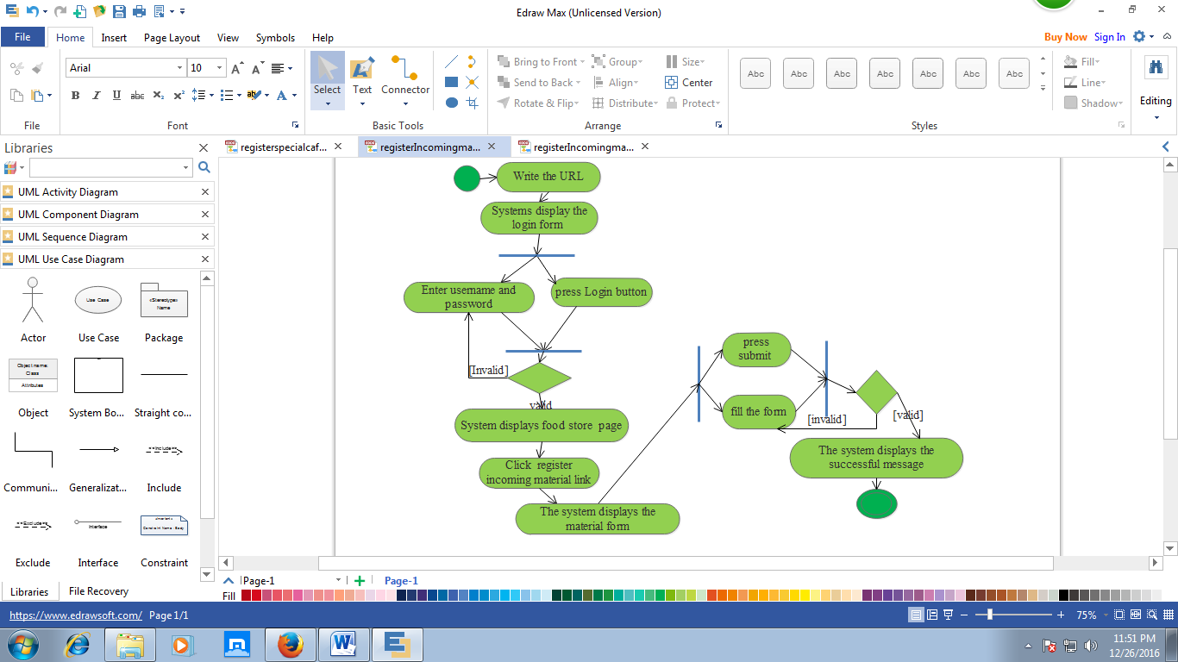

Figure2. 7 activity diagram for register incoming materials

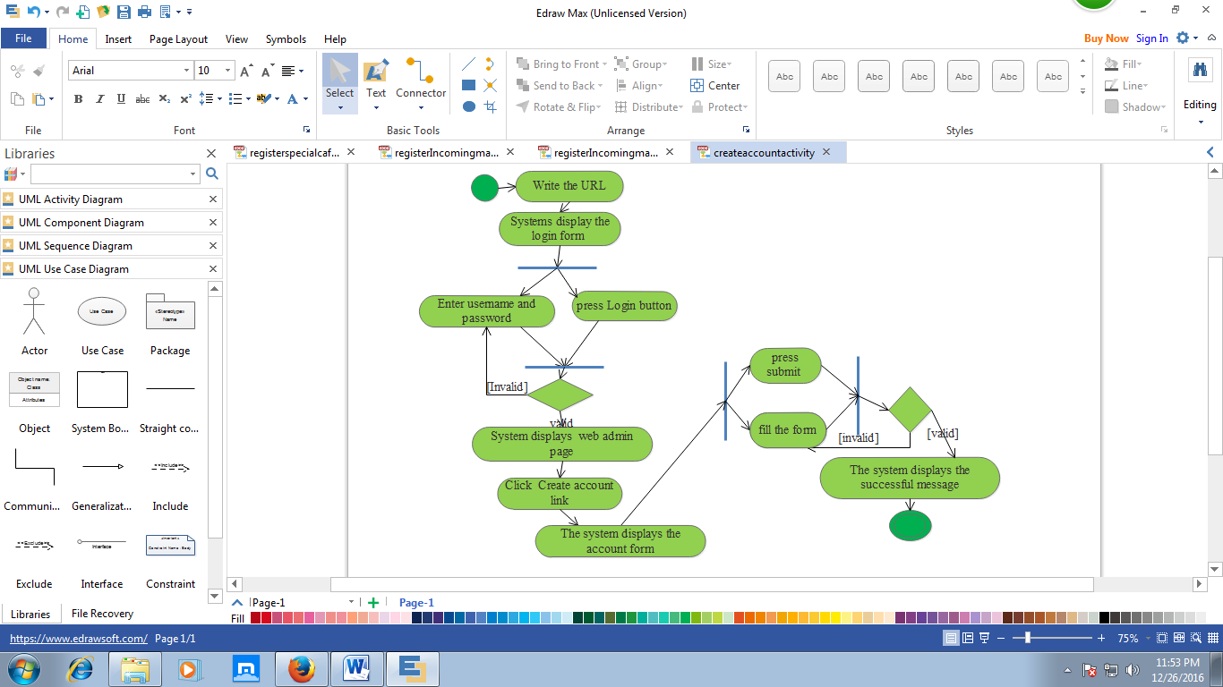

Figure2. 8 Activity diagram for create account

# **2.13 Analysis class diagram**

Class diagrams are useful in many stages of the system design. In the analysis stage, a class diagram can help to understand the requirements of a problem domain and to identify its component.

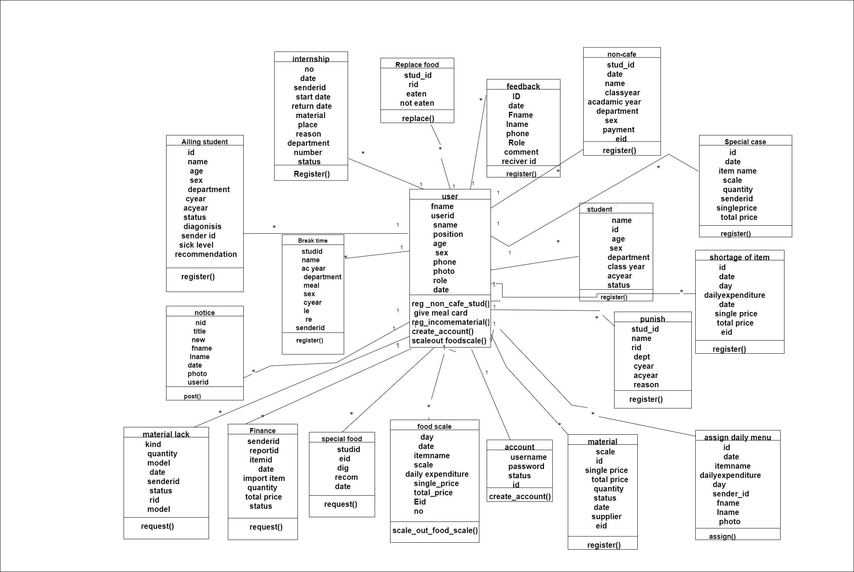

Figure 2. 9 Analysis class Diagram

# **2.14 State machine diagram**

A state machine diagram typically is used to describe a state dependent behaviour of an object. State machine diagrams usually applied to objects but can be applied to any element that has behaviour such as: actors, use cases, methods, subsystems systems and etc. and they are typically used in conjunction with interaction diagrams (usually sequence diagrams).

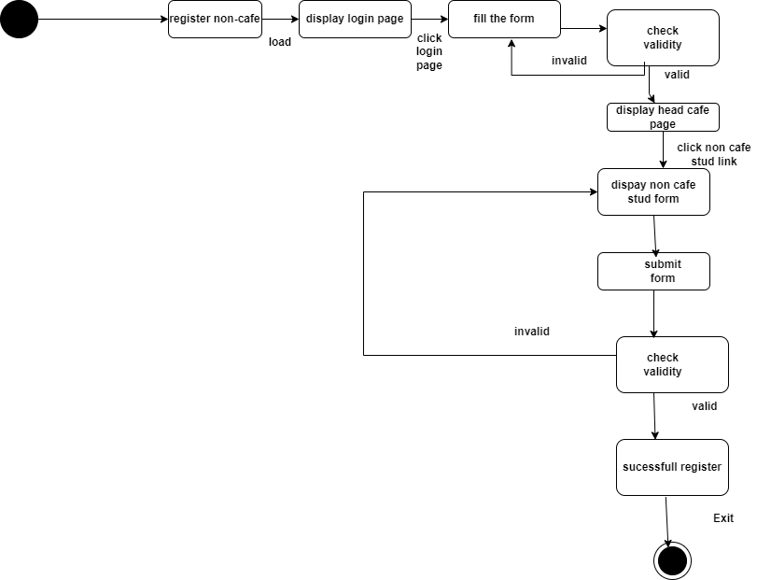

Figure2. 10 state machine diagram for register non café

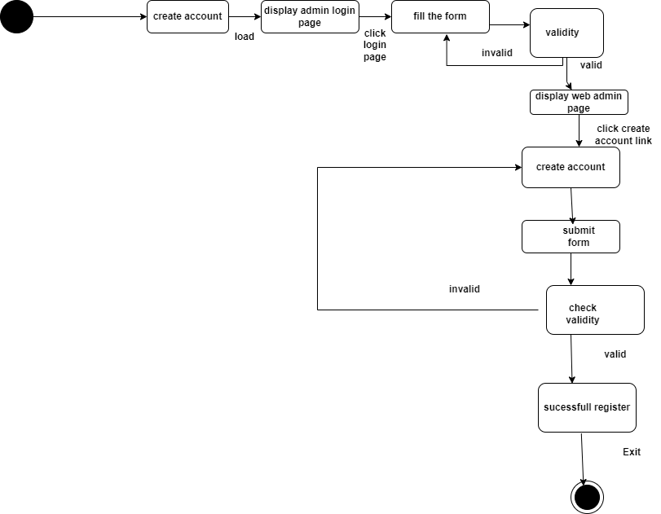

Figure2. 11 State machine diagram for create account

# **CHAPTER 3**

# **3. System design**

System design is the process of defining the components, modules, interfaces and data for a system to satisfy specified requirements.

System design is the transformation of analysis model in to a design model and the detail investigation of system elements from logical view.

# **3.1 design class Diagram**

Design class diagrams are the main building blocks of object oriented modelling.it is used for general conceptual modelling of the structure of application, and for detailed modelling, translating the models in to programming code.

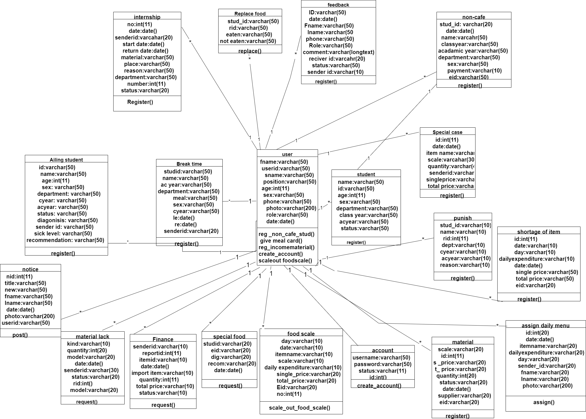

Figure3. 1 Design class diagram

# **3.2 physical data model**

Physical data model is a database specific model that represents relational data objects for example (tables, columns, primary and foreign keys and their relationships. A physical data model can be used to generate data definition language.

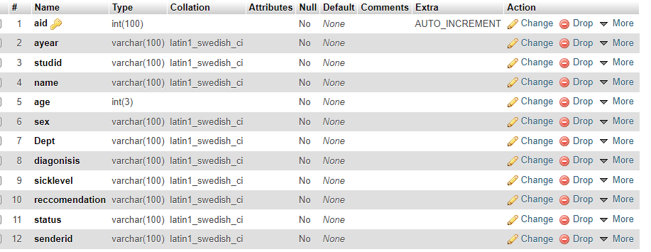

Figure3. 2 physical data model for ailing students

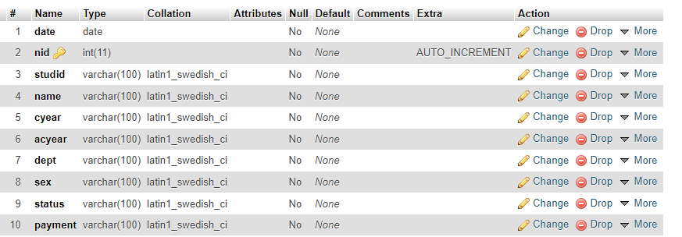

Figure3. 3 physical data model for non-café students

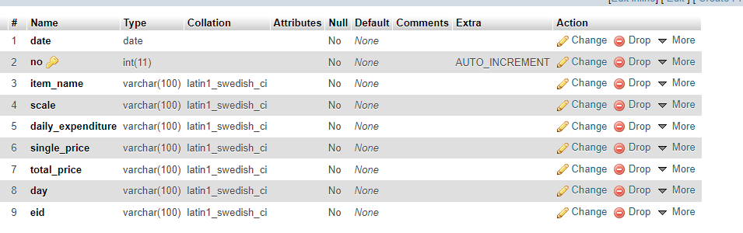

Figure3. 4 physical data model for daily expenditure

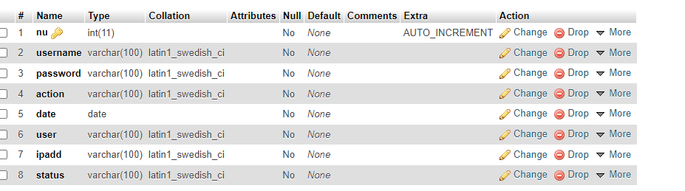

Figure3. 5 physical data model for log file

# **3.3 user interface design**

User interface design focuses on anticipating what users might need to do and ensuring that the interface has elements that are easy to access, understand and use to facilitate those actions. user interface brings concepts together from interaction design, visual design, and information architecture.

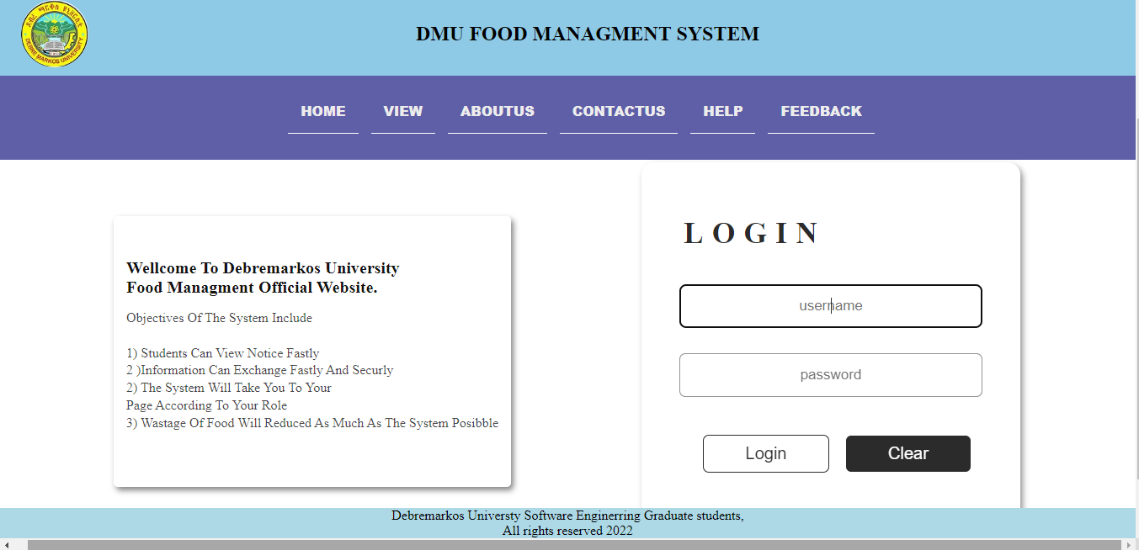

Figure3. 6 main home page interface

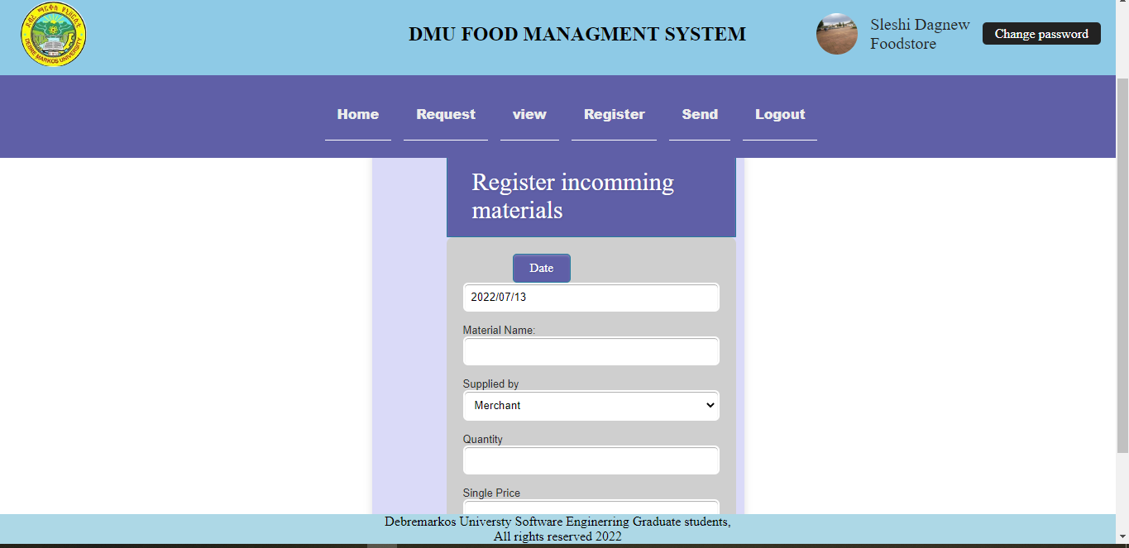

Figure3.7register incoming material

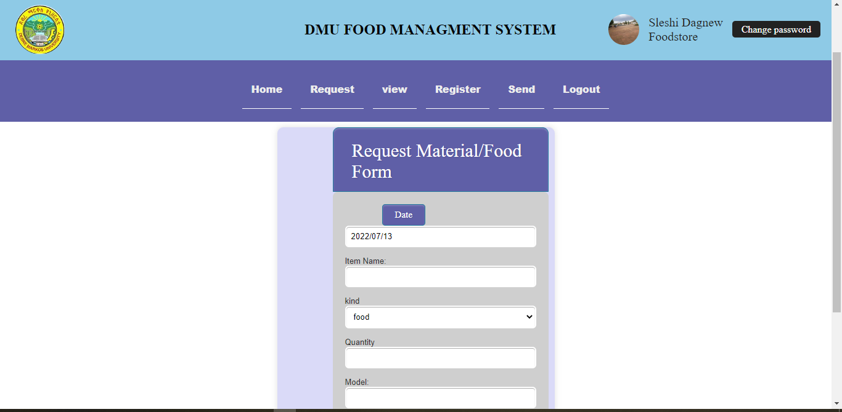

Figure3. 8 request material user interface

# 

# **3.4 deployment diagram**

deployment diagram is a UML diagram type that shows the execution architecture of a system, including nodes such as software and hardware execution environments and the middle ware connecting them.

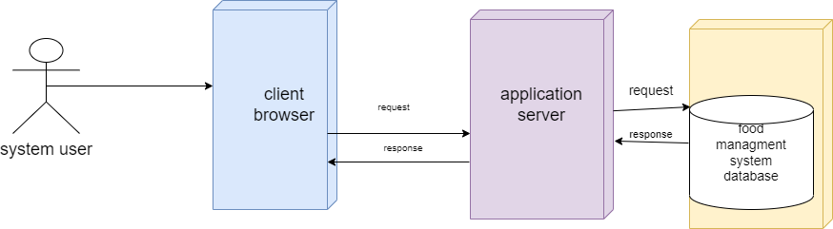

Figure3. 9 Deployment diagram

# 

# 

# **3.5 component diagram**

Component diagram describes the organization and wiring of the physical components in the system. Component diagrams often drawn to help model implementation details and double checks that every aspect of systems required functions is covered by planned development.

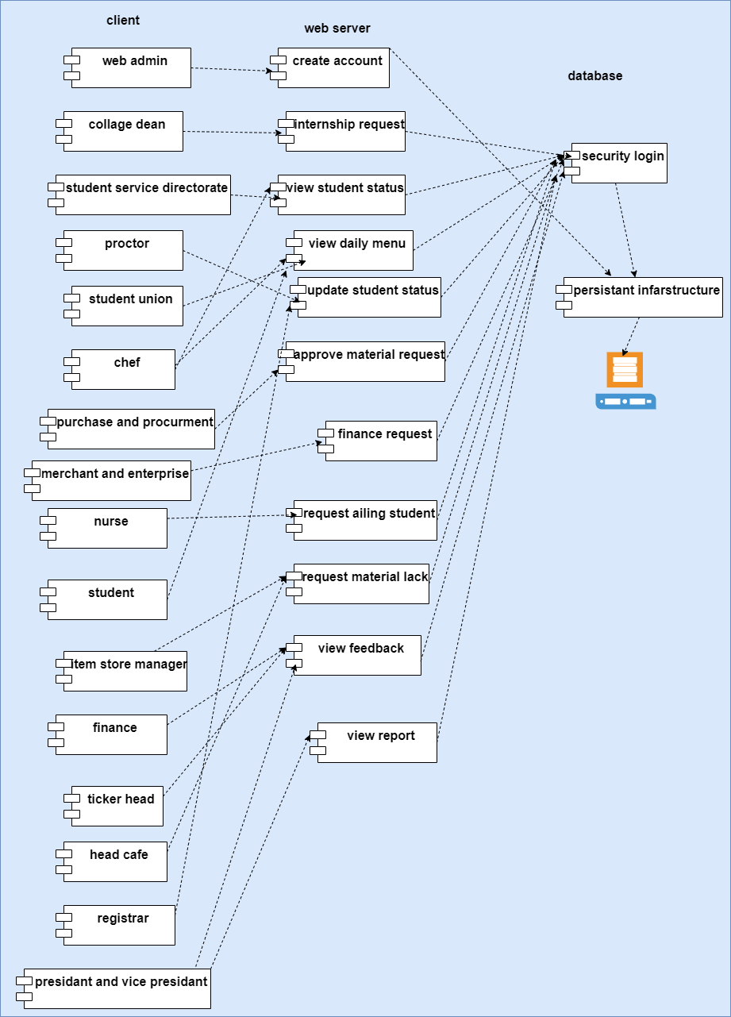

Figure3. 10 Component diagram

# **3.6 communication/collaboration diagram**

A collaboration diagram also known as communication diagram, is an illustration of the intersections among software objects in the unified modelling language. These diagrams can be used to portray the dynamic behaviour of a particular use case and define the role of each object.

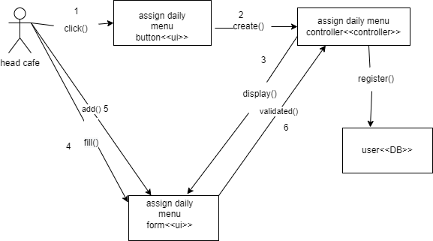

Figure3. 11 collaboration diagram for head café assigning daily menu

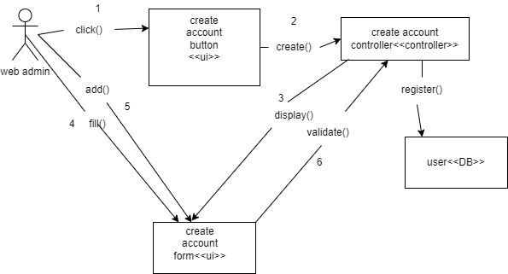

Figure3. 12 Collaboration diagram for web admin creating account

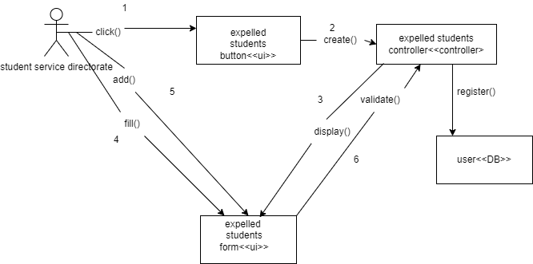

Figure3. 13 Collaboration diagram for student service directorate

# 

# **CHAPTER 4**

# **4 Implementation**

# **4.1** **Overview of the programming language**

For implementing this project, we use the following programming language: -

* PHP **(**We use PHP language for the system development, and our system (software) will be compatible on all hardware platforms such as windows &Linux)
* Scripting language: -used to develop different validations.
* HTML**: -**to display the web page.
* CSS**:** - for the formatting of the web site.

# **4.2 Algorithms Used**

Pseudo code is compact and informal high-level description of a computer programming algorithm that uses the structural conventions of a programming language but is intended for human reading rather than machine reading. The purpose of using pseudo code is that it is easier for humans to understand than conventional programming language code, and that it is a compact and environment-independent description of the key principles of an algorithm.

Load item store page

Open item registration form

Fill

The Login registration form

Click the register button

If (Form is filled)

If (valid)

Generate SQL select queries

Connect to database

Pass queries to database

If (any query fails)

Display error message

Else

Read session

If session exists on database, item is added to food store,

Else

If they're correct

Create session ID

Store session ID on database

Display the page

End if

End if

Else

Display error message

Ask the user to refill the form

End if

End if

# **4.3 sample code for register incoming food item**

<?php

include("../connection.php");

session_start ();

if(empty($_SESSION['user'])) {

header ('location: ../index.php');

}

include("header.php");

include("navbar.php");

?>

<?php

$queryincoming=mysqli_query ($conn,"select *from incomingfood ");

if($queryincoming) {

$row=mysqli_fetch_array($queryincoming);

$quantityincomming=$row['quantity'];

}

$queryshortage=mysqli_query ($conn,"select *from shortageofitem ");

if($queryshortage) {

$row=mysqli_fetch_array($queryshortage);

$quantityshortage=$row['dailyexpenditure'];

}

$querylack=mysqli_query ($conn,"select *from materiallack");

if($querylack) {

$row=mysqli_fetch_array($querylack);

$namelack=$row['itemname'];

}

?>

<?php

$dat=date("Y/m/d");

$tim=date("H:h:i:sa");

?>

<?php

$date=date("Y/m/d");

$time=date("H:h:i:sa");

?>

<?php

if(isset($_SESSION['user']['username'])) {

$username=$_SESSION['user']['username'];

$query1=mysqli_query ($conn,"select * from user where user_id='$username'");

while($query2=mysqli_fetch_array($query1)) {

$uid=$query2['user_id'];

$fname=$query2['fname'];

$sname=$query2['sname'];

$photo=$query2['photo'];

}

}

?>

<!DOCTYPE html>

<html lang="en">

<head>

<meta charset="UTF-8">

<meta http-equiv="X-UA-Compatible" content="IE=edge">

<meta name="viewport" content="width=device-width, initial-scale=1.0">

<link rel="stylesheet" href="../css/forms.css">

<title>Document</title>

</head>

<body>

<div class="form-style-10">

<h2>Registrer Incommming Food</h2>

<form action="" method="POST">

<div class="inner-wrap">

<label><input type="button"value="Date"onclick="dat();"/> <input type="text"name="date" value="<?php echo $dat; ?>" readonly="true"/></label>

<label>Item Name: <input type="text" name="iname" required="" pattern="^[a-zA-Z() ]+"class="demoInputBox"></label>

<label>Scale <select name="scale" >

<option value="kilogram">kilogram</option>

<option value="liter">liter</option>

<option value="packet">packet</option>

<option value="number">number</option>

<option value="tasa">tasa</option>

</select></label>

<label>Quantity <input type="text" name="quantity" required="" pattern="^[0-9] +"class="demoInputBox"></label>

<label>Supplied by <select name="supply" >

<option value="merchant">Merchant</option>

<option value="enterprise">Enterprise</option>

<option value="university">University</option>

</select></label>

<label>Single Price <input type="text" name="sprice" pattern="^[a-zA-Z0-9./ ]+"class="demoInputBox"></label>

</div>

<div class="button-section">

<input type="submit" name="submit" value="Register" class="btnRegister" >

<input type="reset" name="reset" value="Reset" class="btnRegister">

</div>

</form>

<?php

$quan=0;

if(isset($_POST['submit']))

if(isset($_POST['submit']))

{

$date=$_POST['date'];

$inamee=$_POST['iname'];

$scale=$_POST['scale'];

$quan=$_POST['quantity'];

$sprice=$_POST['sprice'];

$sup=$_POST['suplay'];

$tprice=$sprice*$quan;

$sql0=mysqli_query ($conn,"select * FROM incomingfood WHERE itemname='$inamee'");

$num=mysqli_num_rows($sql0);

$rowcheck=mysqli_fetch_assoc($sql0);

if($num=='0')

{

$sql="INSERT INTO incomingfood (date, itemname,scale,quantity,sprice,tprice,eid,supplayer,status) VALUES('$date','$inamee','$scale','$quan','$sprice','$tprice','$uid','$sup','notpay')";

$query=mysqli_query($conn,$sql);

$qa="INSERTINTOuserview(date,time,userid,fname,lname,photo,activity) VALUES('$date','$uid','$fname','$sname','$photo','register new income $quan $scale $inamee')";

$query1=mysqli_query($conn,$qa);

echo '<script type="text/javascript">

alert (" food item is added to store")</script>';

}

elseif($quantityincomming>$quantityshortage || $queryincomming===$name lack) {

$sql=mysqli_query ($conn,"delete from shortageofitem where itemname='$inamee'") or die(mysqli_error());

$sql=mysqli_query ($conn,"delete from materiallack where itemname='$namelack'");

$quantity1=$rowcheck['quantity'];

$sum=$quantity1+$quan;

$id2=$rowcheck['id'];

$price=$rowcheck['tprice'];

$totalprice=$price+$tprice;

$sql2="UPDATE incomingfood set quantity='$sum' , tprice='$totalprice' WHERE id=$id2";

$query9=mysqli_query ($conn, $sql2);

echo '<script type="text/javascript">

alert ("Food item is already available so it will be added")</script>';

}}

?>

</body>

</html>

# **CHAPTER 5**

# **5.1 Testing**

**Unit testing:** -Every module of the System is separately tested. I.e., the team tests every module by applying some selection mechanism. Through this mechanism every module gets tested. If an error occurs correction will be taken without affecting another module.

**Integrated testing: -** In this testing part, all the modules combined together and tested for fitness with each other and with the systems functionality. If error occurs in combining them, the module with problem will be identified and re combined.

**System testing: -** In this testing, the team performs over all functional testing by checking whether it meets the required target.

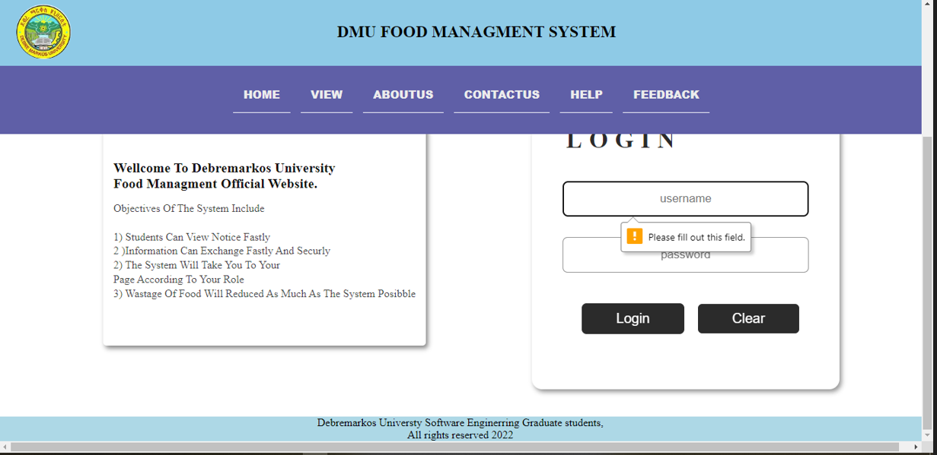

Figure 4. 1 sample test for login

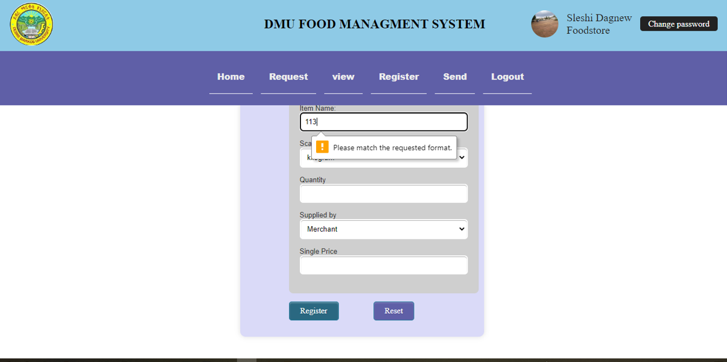

Figure 4. 2 sample test for registering incoming food

# **CHAPTER 6**

# **6. Conclusion and Recommendations**

# **6.1. Conclusion**

The project titled as “Student’s Food management system” is a web-based application. This system provides online student’s information exchange among stakeholders of the food service, facilitate work process, reduce work load for food service workers like head café, item store manager, student directorate and also for other participants. Since the system is developed by user friendly language there is no fear on failures of the system because it can be easily maintainable.

# **6.2Recommendation and Future Enhancement**

## **6.2.1. Recommendation**

We recommend Debre Markos University to use the developed system in order to facilitate the work process and to reduce wastage of food items since the system can calculate everything regarding to food and the system protect the university from being fraud by eligible stack holders.

## **6.2.2. Future Enhancement**

For future enhancement it is better to include the following activities

* The system will be developing that support mobile phone to do the tasks that can do without presenting at work place and notification will address with mobile
* The system will be announced system alert for web admin whenever the change arise that can harm the system and can interrupt this problem.

# **References**

|  |  |
| --- | --- |
| [1] | [online].avilable:, “feasibility study/ivestopedia.com,” Accessed date march 16 2022. |
| [2] | [online], “Avilable:/system requirement specification/prefoce.com,” march 23 2022. |
| [3] | [online].Avilable, “functional and non-functional/altesoft.com,” march 12 2022. |
| [4] | [online].Avilable, “https://www.lucidchart.com/pages/uml-sequence-diagram#:~:text=A%20sequence%20diagram%20is%20a,to%20document%20an%20existing%20process.,” [acessed date march 18 2022. |
| [5] | [online].Avillable, “https://www.geeksforgeeks.org/unified-modeling-language-uml-activity-diagrams/#:~:text=An%20activity%20diagram%20is%20a,the%20activity%20is%20being%20executed.,” [Accessed date march 20 2022]. |

# **Appendences**

The case tools and software’s we used in the project

PHP-is a server-side scripting language used to design the backend.

UML- is a uniform modelling language which we used

HTML-is hyper text markup language which is used to

CSS: - Cascading Style Sheet used to style the interface of web.

Class diagram: Class diagrams show the classes of a system and their interrelationship’s. Class diagrams are often mistakenly referred to as object models.

Use case diagram: In UML, the diagram showing the external actors, the system boundary, the use cases as ellipses, and arrows connecting actors to ellipses or ellipses to ellipses. Primarily useful as a context diagram and table of contents.

Use case: A use case expresses a contract between the stakeholders of a system about its behaviour. It describes the system’s behaviour and interactions under various conditions as it responds to a request on behalf of the stakeholders, the primary actor, showing how the primary Actor’s goal gets delivered or fails. The use case collects together the scenarios related to the primary actor’s goal.